**Seo Report**

**Performance**

**Metrics**

First contentful Paint (2.9 s) First meaningful paint (2.9 s)

Speed Index (48.4 s) First CPU Idle (9.1 s)

Time to Interactive (20.5 s) Max Potential First Input Delay (1.030sms)

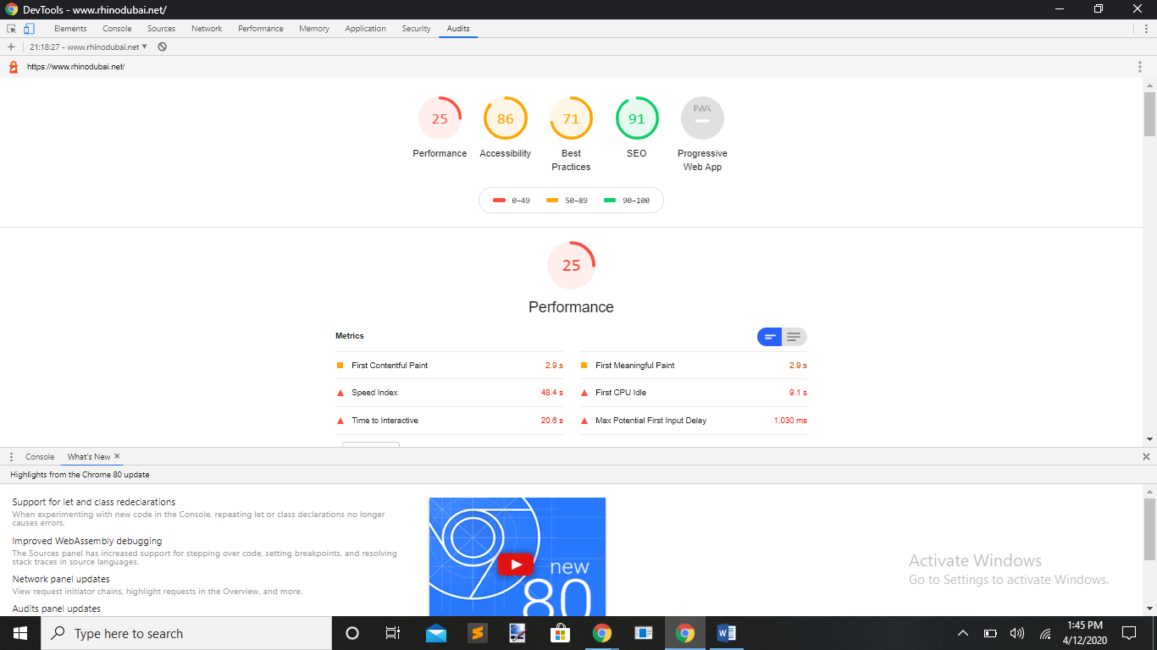

**Opportunities**

Serve images in next-gen formats. (1.35 s).

Remove unused CSS. (0.9 s).

Defer off screen images. (0.3 s).

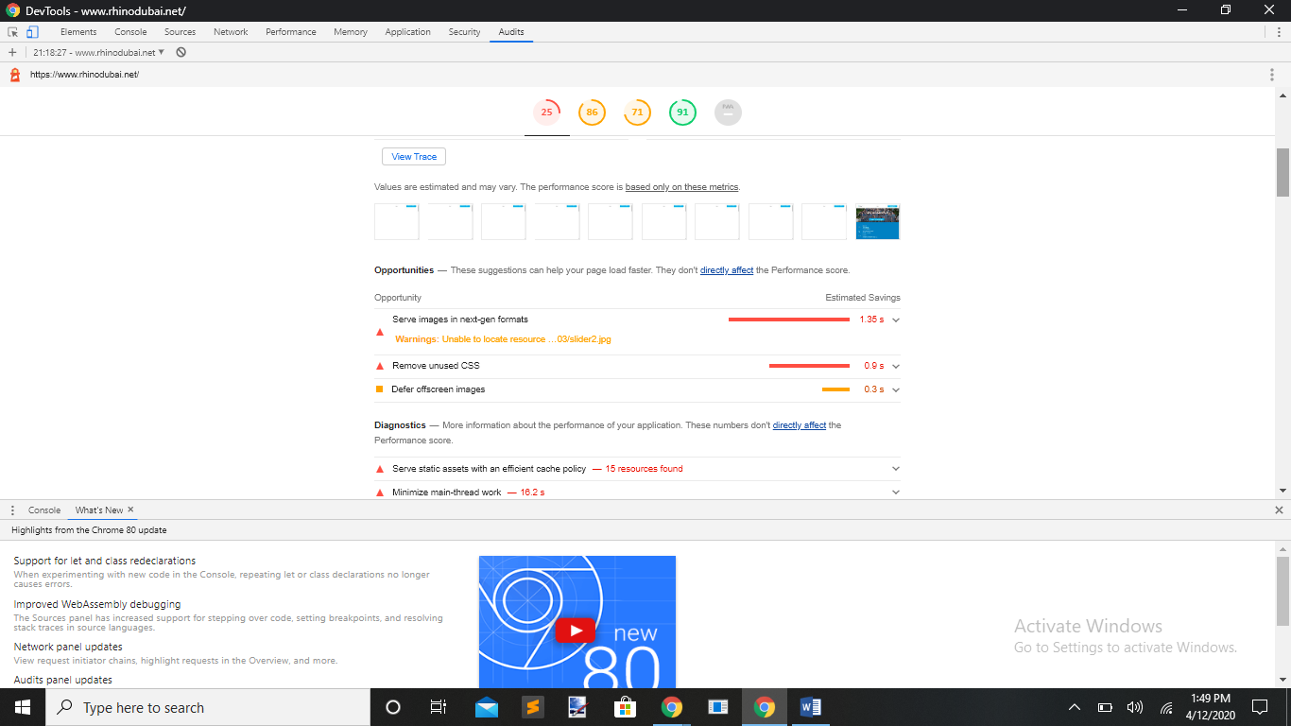To

**Diagnostics**

Serve static assets with an efficient cache policy --- 15 resources found.

Minimize main-thread work. 16.2 s.

Ensure text remains visible during web front load.

Reduce the impact of third-party codes. Third-party code blocked the main thread for 930 ms.

Avoid enormous network payloads. Total size was 5.141 KB.

Reduce java script execution time. 3.4 s.

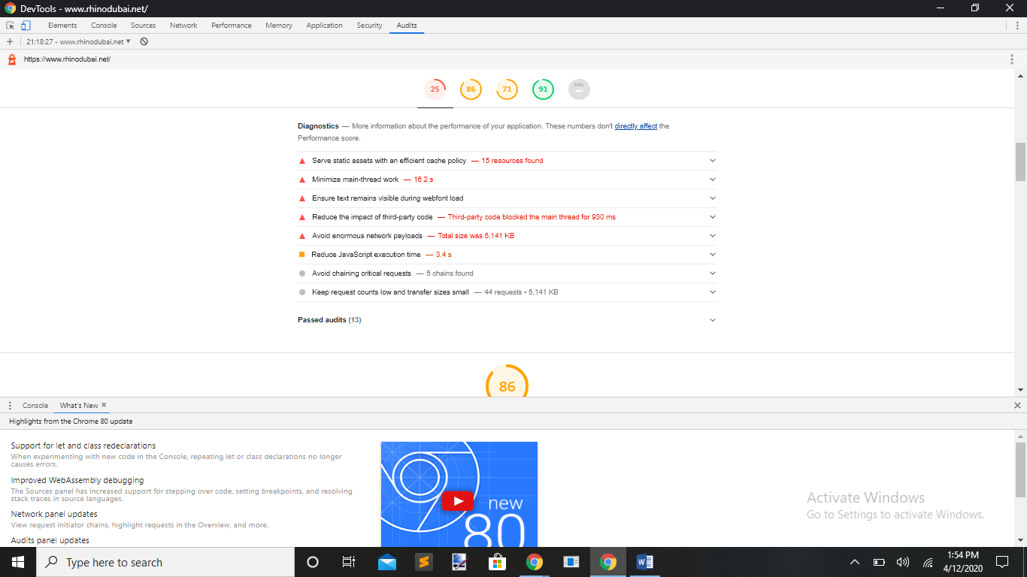

**Accessibility**

**Contrast**

Background and foreground colors do not have a sufficient contrast ratio.

**Best Practices**

[id] attributes on the page are not unique.

**Names and Labels**

Image elements do not have [alt] attributes.

Links do not have a dissemble name.

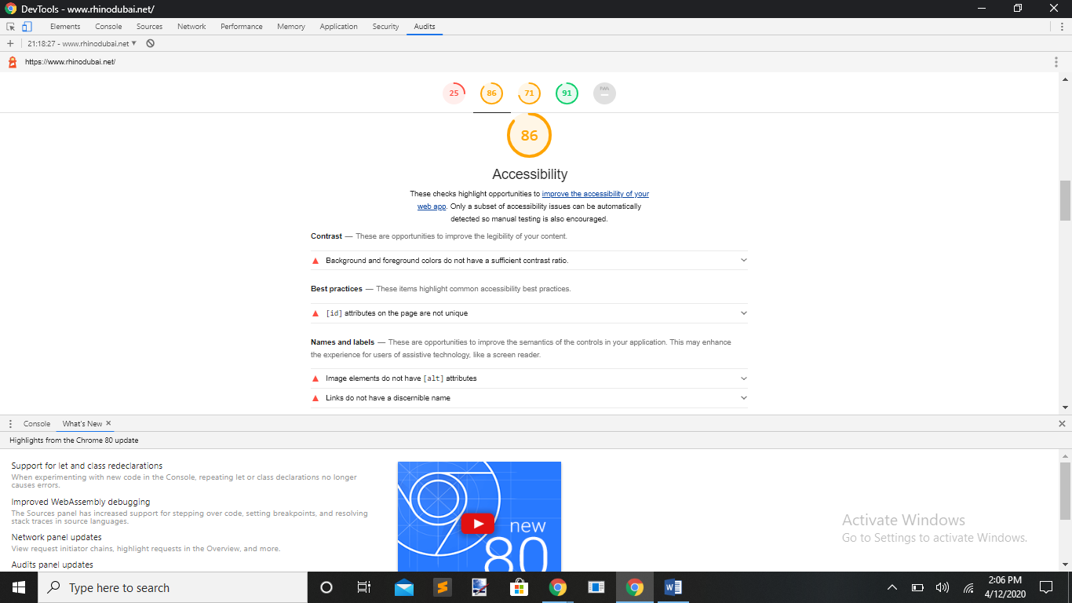

**Best Practices**

Does not use passive listeners to improve scrolling performance.

Links to cross-origin destinations are unsafe.

Includes front end JavaScript libraries with known security vulnerabilities ---- 8 vulnerabilities detected.

Browsers were logged to the console.

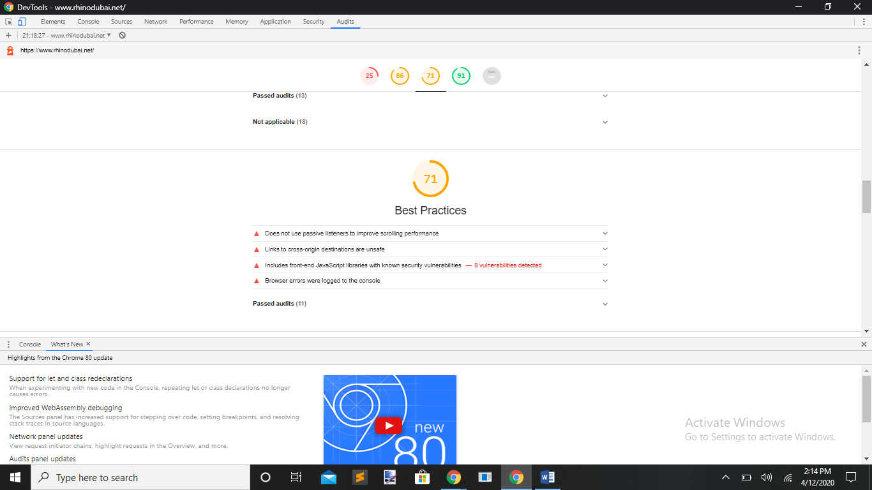

**SEO**

**Content Best Practices**

Image elements do not have [alt] attributes.

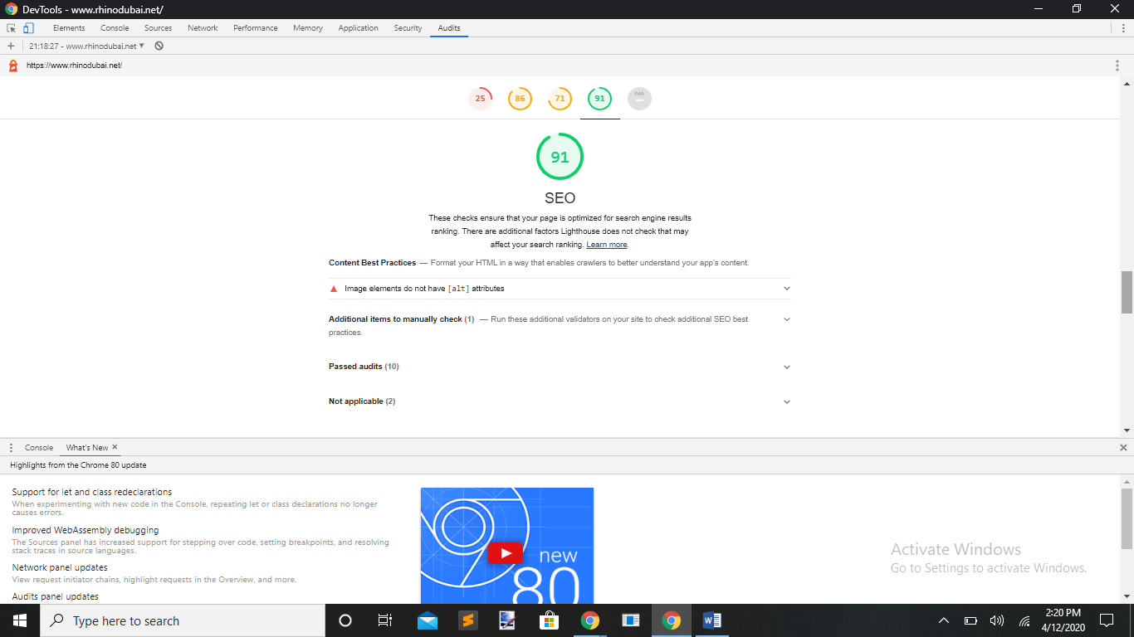

**Progressive Web App**

**Fast and Reliable**

Page load is not fast enough on mobile networks.

Your page loads too slowly and is not interactive within 10 seconds. Look at the opportunities and diagnostics in the ‘Performance’ section to learn how to improve.

---- Interactive at 20.6 s.

Current page does not respond with a 200 when offline.

Start_ur1 does not respond with a 200 when offline. [No usable web app manifest found on the page].

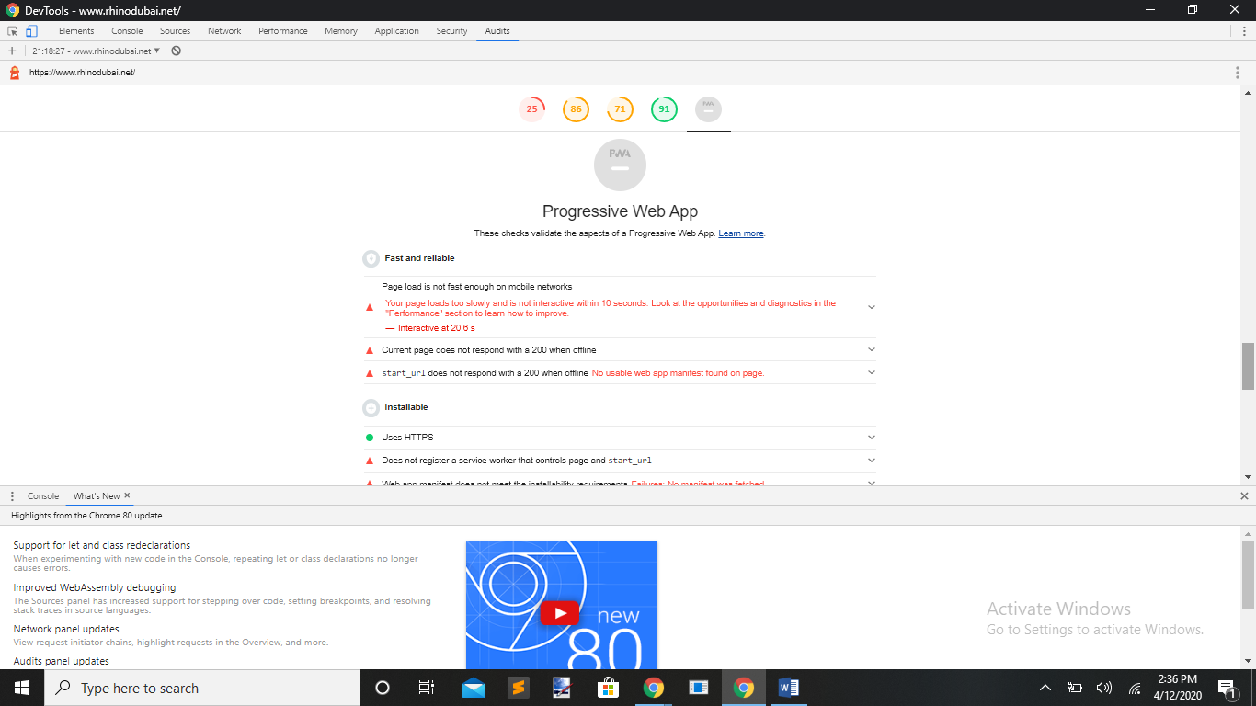

**Installable**

Does not register a service worker that controls page and start_ur1.

Web App manifest does not meet the instalibility requirements. Failures: No manifest was fetched.

**PWA Optimized**

It is not configured for a custom splash screen. Failures: No manifest was fetched.

Does not set a theme color for the address bar. Failures: No manifest was fetched.

No ‘<meta name=”theme-color”>’ was found.

